
June 17, 2016
http://www.burlingtoncountytimes.com/life-style/local-feature/author-s-e-book-focuses-on-activities-for-kids/article_530fecd2-316f-11e6-aee3-57e0e743e149.html
FUN AND GAMES
Author's e-book focuses on activities for kids
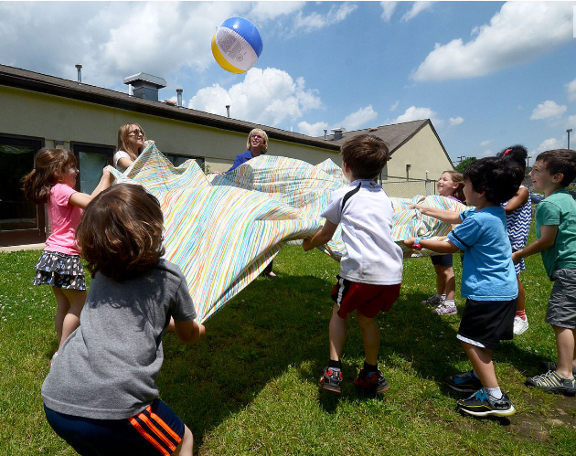
Sharla Feldscher plays with kindergarteners from Randi Simon’s class at Adath Emanu-el in
Mount Laurel. The group attempted to keep a beach ball on a sheet.

There was the sight and sound of happy activity on a recent afternoon in a kindergarten classroom at Temple Adath Emanu-el's preschool.

"This is so cool!" said one young lad, who was part of the delighted circle surrounding a classroom guest, who also happened to be the grandmother of one of the students.

Sharla Feldscher, a born pied piper of children, was the special visitor of the day, and the joy radiated not just from the kids, but from Feldscher as well.
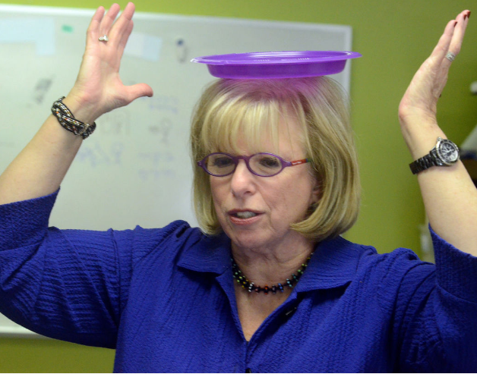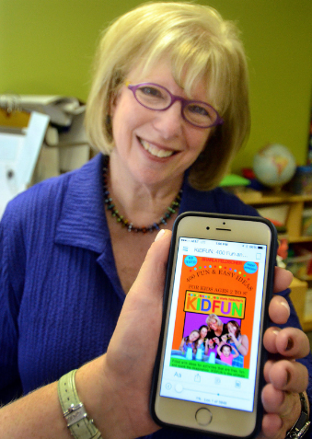
Sharla Feldscher demonstrates one of the games Sharla Feldscher, of Voorhees,
from her book by balancing a plastic plate on her head. Is the author of the e-book “KIDFUN.”

"I've always loved children," said the Voorhees grandmother, who remembered leading the "little kids" in her Philadelphia neighborhood when she was 7 and they were a mere 3 or 4. But her lifelong joy in child's play is anything but frivolous.

Over the course of a long career, Feldscher has combined several lifetimes into one. A graduate of Temple University, she began her professional life as a kindergarten teacher in Philadelphia.

"Parents began asking me how they might occupy their kids at home, and I was thrilled to give them ideas," she said.

Those ideas soon found their way to a popular column in the Philadelphia Daily News for and about kids, one that ran from 1979 to 1987. Feldscher also worked with KYW Radio and even the Phillies and the late Tug McGraw, who joined the party with cartoon-style art for kids.

Their shared passion? Kids and fun.

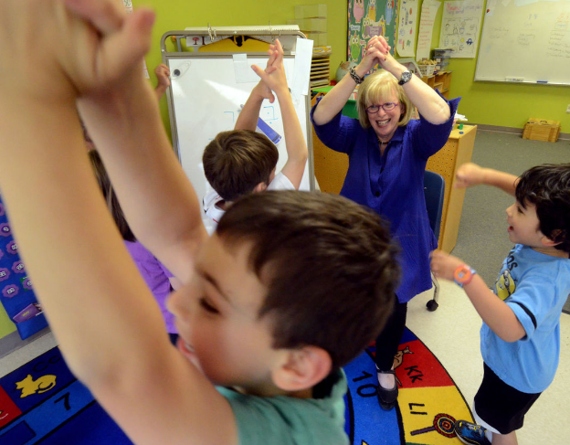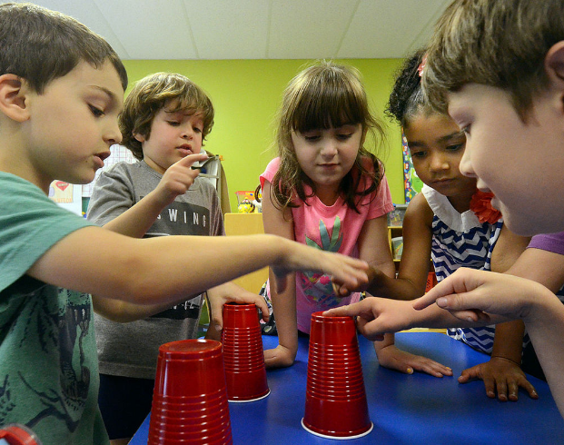
Youngsters raise their arms in victory after “KIDFUN” Kindergartners at Adath Emanu-el in Mount Laurel try to
When author Sharla Feldscher told them the story of figure out what cup holds the white ball as they play the “The Hare and the Tortoise”. Cups in Motion game.

Somehow, Feldscher also managed to become the public affairs director for the Please Touch Museum in Philadelphia, the nation's first museum devoted to children.

She also went on to found a busy public relations firm that bears her name.

Feldscher's first client was Sesame Place in Bucks County, Pennsylvania, and she continues to represent entertainment venues, entertainers and clients that respect her ability to balance serious business promotions with her passion for children.

There would also be six other books on play, including the first edition of the critically acclaimed "KIDFUN Activity Book," published by HarperCollins and translated into German and Russian.

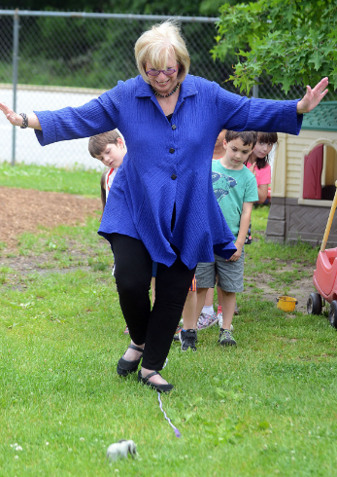
Sharla Feldscher leads kindergartners
at Temple Emanu-el during the Bridge
to Adventure game

In this high-tech age, with 3-year-olds maneuvering their way through iPhones, Feldscher has done something that seems counterintuitive. She has rereleased "KIDFUN" as an e-book, and seeing it reignite fervor in parents, grandparents, baby sitters and teachers as a way to get back to, well, kid fun!

Even in this era of endless technology, there always is a place for playing simple games with kids that actually can bring them joy and delight, Feldscher said.

And at Temple Adath Emanu-el's Early Childhood Center kindergarten, that was abundantly clear.

All it took was the simplest equipment: plastic cups to catch pingpong balls, a bedsheet to flap, a tray of objects that was first viewed full and then reappeared with several items missing, capturing the imagination of young boys and girls, including Sari Horwitz, Feldscher's granddaughter, who was clearly enjoying the fun just as much as her fellow kindergartners.

"I love playing games with my Grammy," Sari said. "And I love her."

Outdoors, the youngsters were endlessly fascinated by bouncing a ball on a sheet, walking a grounded "tightrope" and, with their considerable energy, balancing plastic plates on their heads.

There's a serious side to the rerelease of "KIDFUN," with its 400 ideas for kids 2 to 8. And it has to do with childhood itself.

"I think parents today may have forgotten the things that worked for them and for their parents," Feldscher said. "Just give kids a box of hats, for example, and they'll have a ball. Let young ones wear your clothes, your shoes, your scarves."

But most of all, she advised, "consider the pleasure of having young children who want more than anything to just be with their parents and grandparents. My true wish is that parents take advantage of today, and that they never forget that, for a family, there's nothing better than sharing a great laugh together."

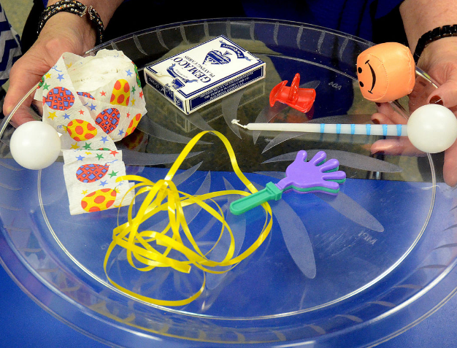

A tray of objects that was first viewed, taken away and then
reappeared with several items missing, captures the
imagination of the young audience.

KIDFUN, published as an e-book by Milky Way Press, is available on Amazon for $5.99. For more information, visithttp://www.coolthings4kids.com/kidfun.html.

