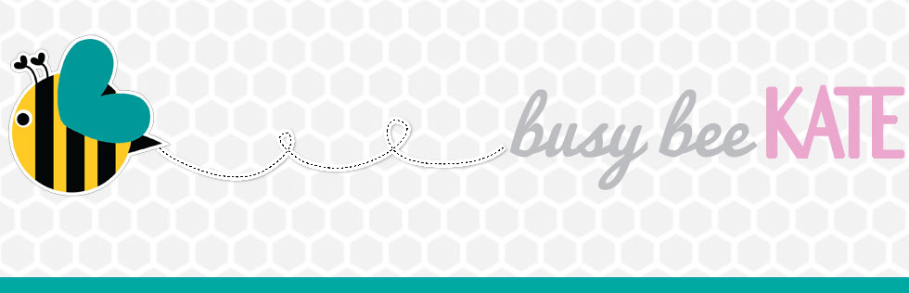
http://busybeekate.com/school-is-out-check-out-the-kidfun-e-book-for-some-fun-summer-activities-ideas/

SCHOOL IS OUT ~ CHECK OUT THE KIDFUN E-BOOK FOR SOME FUN SUMMER ACTIVITIES & IDEAS!
Disclosure: I was invited to be in the review group from Sharla Feldscher and I received a copy of her e-book for free. My opinions are my own and I was not paid or required to write this review.
As a Mom to a 3 year old I am always looking for things to do that are creative and fun, but I must be honest, my mind goes blank sometimes and I start running out of ideas. While I like to hop on Pinterest for inspiration I can get lost in that sea so easily and find myself pinning organization tips or recipes when I really just was looking for something fun to do for the next hour with my daughter, not pining for the next hour!
Sharla Feldscher has come to the rescue and just in time for Summer. She is the author of seven books on creative play, and most recently created an updated e-book of KIDFUN—400 Fun & Easy Ideas for Kids Ages 2 to 8.
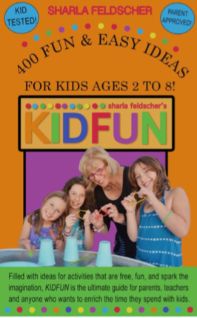
KIDFUN…400 EASY & FUN IDEAS FOR KIDS 2-8
KIDFUN appeals to parents, grandparents, babysitters and anyone who spends time with children. This ultimate guide to fun with kids, first published in 1995, shares amazingly easy and free ideas to inspire creativity. KIDFUN is available on Amazon.com to purchase for $5.99.

KIDFUN is filled with hundreds of simple suggestions and ideas for having fun. With many years of experience writing, and a background in education she has many wonderful and creative ideas that have been kid tested over the years.
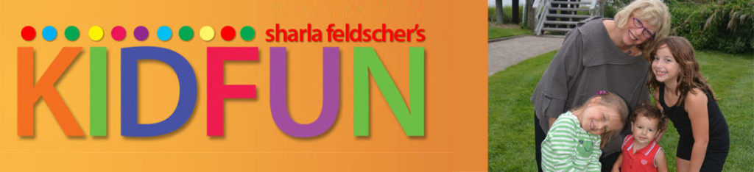
I couldn’t wait to get my hands on this book, it is filled with so many activities. Some of the activities are for very young children. Others work better for school-age kids.
The book is arranged by type of activity, with most of them being simple, short, and direct. So even if you don’t have a large block of time, and just wanting to make a ride home stuck in traffic a little funner, there are so many great ideas. The ideas are low cost and lots of fun. And when supplies are required, they are mostly items easily found in households with children, such as pillows, sponges, or plastic containers.
There is also a wonderful introduction in the book, which I really enjoyed reading. Sharla helps parents to reflect on their young children, remembering what it was like to see the world and everything around it as new and open for exploration, and as an experience to learn while having fun.
“Props for fun are all around us!” says Sharla Feldscher. “Simple household items can provide hours of fun,” she emphasizes and names a few: “Paper plates and flashlights. Drinking straws and tape. Plastic cups and ping pong balls!” Known as “Grammy” to her three granddaughters, Feldscher confides, “I love it when my granddaughters teach me a KIDFUN game. After all, anyone can play KIDFUN! It just takes a little spark of imagination for a creative adventure.”
KIDFUN activities include simple games that can be played while waiting at a restaurant, traveling in the car, at the beach, while sick in bed, on a rainy day, or anytime a bored kid wants something to do. “The purpose of KIDFUN is to turn the switch on creative play and encourage families to laugh together and enjoy each other,” Feldscher emphasizes.
She added, “Even with access to computers, iPads and cell phones, kids still love to put on shows, play dress up, make giant sculptures out of blocks or rocks, and get down on the floor to share a belly laugh with their family. There is no better gift for a child than time spent with the adults they love and admire.”
This week I have used some of the activities throughout our day, and have many of activities in the back of head – almost like a “bag of tricks” to pull out when my daughter is bored, getting restless, or when I’m just looking to switch things up for her. This book will definitely be a resource that I visit often, especially in the Summer when school is out and my mind seems to also want to take a vacation at times.
Sharla has graciously allowed me to share some of her KIDFUN activities with you, and these activities below are perfect especially for the upcoming Summer months.
Painter for Hire
My daughter loved the Painter For Hire activity. To be allowed to paint the house, the mailbox, the steps ~ there really were no rules or limits with this activity which she really enjoyed. Like most kids she really loves any excuse to be able to use water! Below is an excerpt from the book:
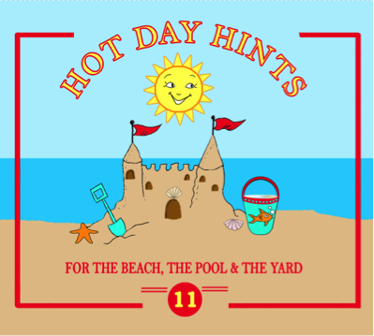
Give your child a bucket of water and a wide paintbrush, and he can be busy painting for hours. He may decide to pain the cement by the pool, the sliding board, benches, toys—anything that will not be damaged by water. He will be fascinated to see how quickly the water is evaporated by the sun.
If you’re not by a pool, he might like to paint the outdoor furniture, the steps and railing. How about the front or back door? He could even paint YOU! After all, a little water never hurt!
Talk Like Me
Another fun activity from the KIDFUN book is Talk Like Me. This is a great one for those long summer road trips. We had so much fun talking fast, and slow, and in different pitches. I enjoyed this activity just as much as my daughter did! Below is an excerpt from the book:

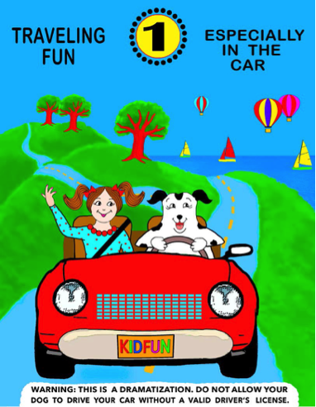
It is amazing what dramatic affects you can get simply by changing your speaking style. A child can develop sound-discrimination skills by playing with his voice in any number of ways.
Try it like this. Count, say the alphabet, or recite a nursery rhyme in your normal manner. Now change your speech: Talk very fast or slow, use a high pitched voice and then a deep bass voice; break everything up into choppy syllables, or put an accent on every third word, and so on. Challenge your child to mimic you exactly as he heard you.
Most children love this kind of word play, and they learn much about words and speech by playing with their voices. For instance, you can turn “Mary Had a Little Lamb” into a love poem, a mystery, or a proclamation simply by varying your speech pattern. Try reciting it the way you think a Frenchman or a German or a Chinese or a southerner might.
How Far Is It?
Another fun activity to share is How Far Is It. This easily became a game also of how fast and how slow is it. Each time we retried to see how far things were it became a race to see who could reach the object fastest. It was also a fun way to get in a little exercise and movement. Below is an excerpt from the book:
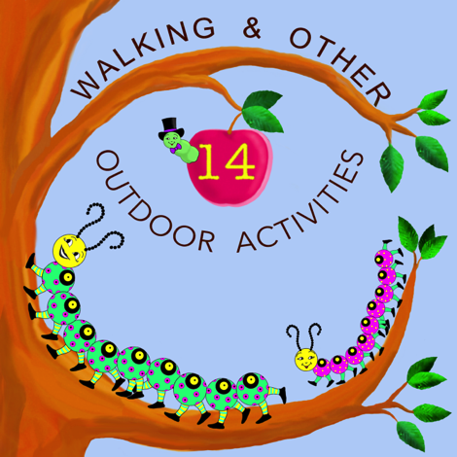
As you are walking with your child, pick out some object in the near distance—the fire hydrant, for example. Then count the steps you take until you reach the object. Then pick another object. Compare how far away in step measurement different objects are. Try to estimate how many steps it will take to get to a close object. For example, if it took twenty-three paces to reach the mailbox, guess whether it will take more or less to reach the trash can.
You can walk in regular paces to one spot, then turn around and see how many fewer steps you need if you take giant steps walking back.
With the Summer months ahead of us and school on recess this book will help you keep the kids busy, learning, engaged, and most importantly to them is that they are having fun! Having fun while learning is the best motivator when teaching a young child, in school and at home. And KIDFUN activities are designed to be easy and simple, so no special supplies needed.
Also be sure to check out Sharla’s blog where she posts new KIDFUN activities www.kidfunandmore.com.
KIDFUN—400 Fun & Easy Ideas for Kids Ages 2 to 8 is available on Amazon.com to purchase for $5.99.
Happy Summer!

